LESSON PLAN
The Boston Massacre
Mission US TimeSnap is an interactive learning experience that combines an immersive game and evidence analysis to engage and support learners in the development of historical thinking skills and understanding of key events in U.S. history.

TABLE OF CONTENTS

Overview 1

Schedule (VR & Web Streaming) 2

Mission Brief 4

Mission Debrief 5

Field Note Analysis 7

Class Discussion Guide 10

Performance Task Guide 12

Appendix 15

OVERVIEW
How did the Patriots and the British each explain the
causes of the Boston Massacre?
Event Overview: On March 5, 1770, five men were fatally shot by British soldiers in Boston’s King Street. While some details of this event are disputed, most witnesses agree that a crowd had gathered that evening in front of the Customs House, and words were exchanged between the angry crowd and the soldiers, who were standing in a semi-circle with fixed bayonets. The crowd was throwing snowballs and, according to some witnesses, ice and sticks. Someone was heard to yell “Fire” and the soldiers fired into the crowd.

Although war would not be declared between the colonies and Great Britain until 1776, this confrontation—and its portrayal by Paul Revere as a massacre of innocent civilians—is widely seen as a key event on the road to Revolution.

Guiding Questions: What earlier events contributed to the outbreak of violence? How did each side—the Patriots and the British—interpret these events, and explain the causes of the Boston Massacre? How did these different perspectives contribute to the coming of the American Revolution?

THE EVIDENCE  - Students’ Field Notes produced while using the VR interactive or web streaming experience.  - “The Bloody Massacre perpetrated in King Street Boston on March 5th 1770, by a party of the 29thRegt., 1770” by Paul Revere | OBJECTIVES  - Identify the causes of the Boston Massacre  - Analyze and compare different perspectives on the Boston Massacre | MATERIALS  - TimeSnap Lesson  - Classroom plan and Instructions  - Mission Intro Script  - Documents & Document Analysis Worksheets  - TimeSnap VR App or web stream  - TimeSnap VR Field Notes

SCHEDULE: FOR VR EXPERIENCE

CLASSROOM PLAN FOR BLOCK PERIODS (80-90 minutes)
Assumes 2:1 student to device ratio

DAY 1
- Educator Intro (5 mins)
- Assign class into group A and group B (if a different student to device ratio, more or fewer groups will be needed)
- Group A VR Time (20-30 minutes)
  - Group B: Reading or teacher-assigned activity
- Group B VR Time (20-30 minutes)
  - Group A: Reading or teacher-assigned activity
- Whole class Mission Debrief (10 mins)
DAY 2
- Field note analysis worksheet (15 mins)
- Guided class discussion (25 mins)
- Performance task: Document Analysis (15 mins)

CLASSROOM PLAN FOR NON-BLOCK PERIODS (40-50 minutes)
Assumes 2:1 student to device ratio

DAY 1
- Educator Intro (5 mins)
- Assign class into group A and group B (if a different student to device ratio, more or fewer groups will be needed)
- Group A VR Time (20-30 minutes)
  - Group B: Reading or teacher-assigned activity

DAY 2
- Group B VR Time (20-30 minutes)
  - Group A: Reading or teacher-assigned activity
- Whole class Mission Debrief (10 mins)

DAY 3
- Field note analysis worksheet (15 mins)
- Guided class discussion (25 mins)

DAY 4 ( OR DAY 3 HOMEWORK)
- Performance task: Document Analysis (15 mins)

SCHEDULE: FOR WEB STREAMING EXPERIENCE

CLASSROOM PLAN FOR BLOCK PERIODS (80-90 minutes)
Assumes 1:1 student to device ratio

DAY 1
- Educator Intro (5 mins)
- Gameplay (20-30 mins)
- Field note analysis worksheet (15 mins)
- Guided class discussion (25 mins)
- Performance task: Document Analysis (15 mins)

CLASSROOM PLAN FOR NON-BLOCK PERIODS (40-50 minutes)
Assumes 1:1 student to device ratio

DAY 1
- Educator Intro (5 mins)
- Gameplay (20-30 mins)
- Whole class Mission Debrief (10 mins)

DAY 2
- Field note analysis worksheet (15 mins)
- Guided class discussion (25 mins)

DAY 3 (OR DAY 2 HOMEWORK)
- Performance task: Document Analysis (15 mins)

MISSION BRIEF
Educator Intro Script (5 minutes)
Mission US TimeSnap is an interactive learning experience that combines immersive gaming and evidence analysis to engage and support learners in the development of historical thinking skills and understanding of key events in U.S. history.
To begin, read and/or paraphrase the following intro script to the class.

Today we’ll be using a virtual reality game, Mission US’s TimeSnap to explore the Boston Massacre. You may or may not already know something about this event. Here’s what happened in a nutshell: On March 5, 1770, five men were fatally shot by British soldiers in colonial Boston. While many details are disputed, most witnesses agree that a crowd had gathered that evening on King Street and that words were exchanged between angry townspeople and the soldiers, before the soldiers fired their weapons.

In this game, you play a field agent at Chronological Advanced Research Projects Agency (C.A.R.P.A), a fictional government agency dedicated to recovering the past in order to improve the present. One main goal of C.A.R.P.A. is to rebuild the world’s archives. C.A.R.P.A has engineered a virtual form of time travel that recreates scenes from the past.

Your Mission is to discover the causes of the Boston Massacre. Why did British soldiers kill five civilians in March 1770? What events in the weeks and years before led to this fatal confrontation? Once you complete your mission, you will be asked to consider how each side—the Patriots and the British—interpreted these events. What did they view as the causes? Who (or what) did they see as primarily responsible? And how did their version of events differ?

You will answer these questions by “Time Snapping” to 1770 King Street, a full six years before the signing of the Declaration of Independence and the formal onset of war. You will explore a series of coordinates related to the massacre and collect field notes. When you return to your home base, you will file a mission report explaining what caused the Massacre and why.

MISSION DEBRIEF
Entire Class Activity Guide for non-block periods (10 minutes)

In this guided discussion, collect students’ first impressions from the TimeSnap mission and help them make sense of events chronologically. First, you will elicit the events they remember from the experience that lead up to the Boston Massacre, and then you will ask them to list the individuals they interacted with. They will use this information when they go to fill out their field notes. If students do not come up with events or people, it is OK to help remember.

TEACHER PROMPTS:

(Optional: Use Slide while discussing events)

- Let’s review your mission. You were asked to discover why five civilians were shot and killed by British soldiers on King Street in 1770. Before you go work on your own, let’s discuss what we think led to this confrontation. In the TimeSnap mission, you read and heard about a number of different events that took place around that time. Can someone tell me what events you remember hearing about?
Teaching note: If not using slide, list the events that lead up to the Boston Massacre with students. Events include: passing of the Townshend Act, occupation of Boston by British soldiers, fight at the ropewalk

- When did each event take place relative to the Boston Massacre? Which event took place first? Next?
Teaching Note: While students are unlikely to be able to offer exact dates, they should be able to work out a relative chronology.

(Reveal the full chronology)

- Since we’re interested in identifying causes of the confrontation, we can forget about these events after the massacre for the moment. The events that took place before March 5, 1770 are all potential causes of the Massacre.
a. What about the people you met? Did anybody stand out?
Teaching Note: Help students elicit the people they spoke with during the VR experience. Those people include: Paul Revere, Captain Preston, people in the tavern, the tavern keeper, the ropewalk worker, etc. Ideally, students will remember at least Revere and a captain figure. If students don’t come up with people’s names you can help them.
b. What did Revere think about the Massacre?
Teaching Note: “Blamed the British”, “anti-British”, etc
c. The Captain of the British soldiers who was present the night of the confrontation—Captain Preston. What did he say about the Massacre?
Teaching Note: “Said colonists were rowdy”, “said he was innocent”, etc.

- Who else did you meet?
Teaching Note: People in the tavern, tavern keeper, ropewalk worker, angry man, etc
a. What did they have to say about the Massacre?
Teaching Note: Revenge for ropewalk fight, smuggling of taxed goods, taxes on consumer items, Capt Preston and soldiers are guilty of murder, nobody knew what was going on, everybody shares blame, etc.

FIELD NOTE ANALYSIS
Activity Guide (15 minutes)
Students will now use their CARPA field notes to write about two causes that contributed to the Boston Massacre. You can distribute the field notes and have students work in pairs. The text below is the directions from the worksheet they will complete.
NOTE: The text below is from the Field Note Analysis student worksheet. Feel free to read this text with students before they start)

Your field notes were logged automatically by CARPA’s A.I. technology as you explored colonial Boston. The A.I. has pre-sorted these notes by category, tagged each note with the source of that information, and starred the notes that directly conflict.

To complete the CARPA Debrief Protocol, use your field notes to explain how these causes contributed to the Boston Massacre.

Working in pairs...
- Review your field notes;
- Compare what you found with a partner;
- Answer the following questions.

NOTE: Below are questions students will answer using their CARPA field notes that are produced during the VR game.
We’ve provided example answers in blue for your reference.

1. Select two major causes from before March 5, 1770 for further analysis.

- Cause #1: ___________Ropewalk Fight__________

i. How did the events, people, or circumstances mentioned in this cause build tension
in Boston before the Massacre?

The ropewalk fight built tension between the British soldiers and the colonists because the colonists felt British

soldiers were taking their jobs and it was another example of how both sides felt the other was insulting them.

ii. How many sources provided evidence about this cause? List the sources below.

2 sources provided evidence about this cause: Captain Preston and a tavern customer

- Cause #2: _______Taxation____________________________

i. How did the events, people, or circumstances mentioned in this cause build tension in Boston before the Massacre?

Colonists were angered by British taxes because they didn’t have any representation in Parliament. They

protested paying taxes and joined the Sons of Liberty.

ii. How many sources provided evidence for this cause? List the sources below.

2 sources provided evidence about this cause: Revere and CARPA.

2. Review your field notes about the night of the Boston Massacre itself.

- Using your and your partner’s field notes, describe what happened on March 5, 1770. Include any information about what happened immediately before, during, and after the shooting.

On the night of the Massacre, there was a crowd around the British soldiers, and then

soldiers started shooting. Some people said the crowd was rowdy and armed, but some
people said it was peaceful.

- Review any conflicting field notes about what happened on this day from this category. What are the sources? Why might each of these sources have described the Massacre differently?
Captain Preson said that the crowd was armed and that he didn’t order his soldiers to fire. He might

say that because he is a soldier and also was being accused of murder. Revere said that the crowd was peaceful

and that Captain Preston ordered his soldiers to fire. He didn’t like the British soldiers because he opposed
British taxes.

- Consider the causes you analyzed above in Part 1. How did the combination of different causes lead to the outbreak of violence on the night of March 5? How do you think they affected the way each source described the Massacre?
Taxation and the Ropewalk fight both increased tension in Boston because they caused colonists to clash

with soldiers before. Taxation made the colonists dislike the British, and the soldiers came to enforce the

British taxes. When they got there, the British soldiers had to complete with the colonists for extra work, which

made the colonists dislike them even more and made the British soldiers feel insulted. The soldiers saw the

colonists as troublemakers, and the colonists saw the soldiers as oppressors, which led them to see the Massacre differently.

CLASS DISCUSSION
Activity Guide (25 minutes)
In this guided discussion, you will debrief the CARPA Field Notes activity by discussing the potential causes of the Massacre and establish concrete reasons HOW each event connects to the Massacre.

Then, you will discuss conflicting evidence students have gathered in order to explore how historians deal with conflicting or fragmentary evidence.
TEACHER PROMPTS—THE CAUSES OF THE MASSACRE:

1. What causes did you/your group analyze?
Teaching notes:
- Ideally, every major contributing factor will be named by at least one group, but if not, suggest the major factors.
- Teaching note: Major contributing factors: Townshend Acts/taxation, landing of troops/military occupation, ropewalk fight/tensions in Boston.

2. How did each cause create tension in Boston? How did that tension eventually lead to the deaths of five people?
Teaching note: Create cause/effect map with all events leading to the Massacre.

3. Ask students to look back at their field notes. Which events have multiple sources of evidence?
Teaching note: Some examples are the arrival of the troops in 1768 and military occupation, the fight at the ropewalk.

TEACHER PROMPTS—CONSIDERING CONFLICTING EVIDENCE

1. Did you collect any conflicting evidence? What does this tell us about the event?
Teaching notes:
- At least some students should have conflicting pieces of evidence
- Students should understand that it is difficult to know exactly what happened in the past

2. Our job is to try to sort through this uncertainty as best we can. For example, one source said Preston gave the order to fire, another source said he didn’t. Can both be true? Do we have enough evidence to know who to believe?
Teaching notes:
- Both can’t be true, because Preston either gave the order or didn’t
- Responses will vary—but students should understand that it is hard to say for sure who is right

3. One source said the soldiers harassed the townspeople, another source said that the townspeople harassed the soldiers. Can both be true?
Teaching Note: Both can be true, because it depends on your perspective - possible that soldiers mistreated townspeople, and townspeople mistreated soldiers

4. Why do you think the disagreement over who caused the massacre mattered in 1770?
Teaching Note: Students might speculate (or already know) that the Boston Massacre is one of the “causes” of the American Revolution. Ask them to explain how they think the Boston Massacre might have lead to the American Revolution (e.g. worsened sense of “us”and “them,” first time people died from troops, the Patriots used it as propaganda, etc.)

5. What can we learn from the Boston Massacre today?
Teaching Notes:
- The same event can be perceived very differently, depending on your perspective.
- It is not always possible to determine all the facts.

6. Ask students to write a short synopsis explaining the causes of the Massacre. Distribute the “C.A.R.P.A. Mission Report” worksheet, or just give verbal instructions.
Student instructions: Individually or with your partner, write a 3-5 sentence Mission report explaining the causes of the Boston Massacre. You must include:
- More than one cause
- A clear explanation of how that cause led to the Massacre
- More than one source of information.

PERFORMANCE TASK GUIDE
Document Analysis: The Bloody Massacre Engraving (15 minutes)

Students will revisit the “Bloody Massacre” engraving they encountered in the VR and apply the concepts considered during their class discussion. You can distribute the worksheet and have students work individually. The text below is the directions from the worksheet they will complete.
Note: The text below is from the Document Analysis student worksheet. Feel free to read this text with students before they start)

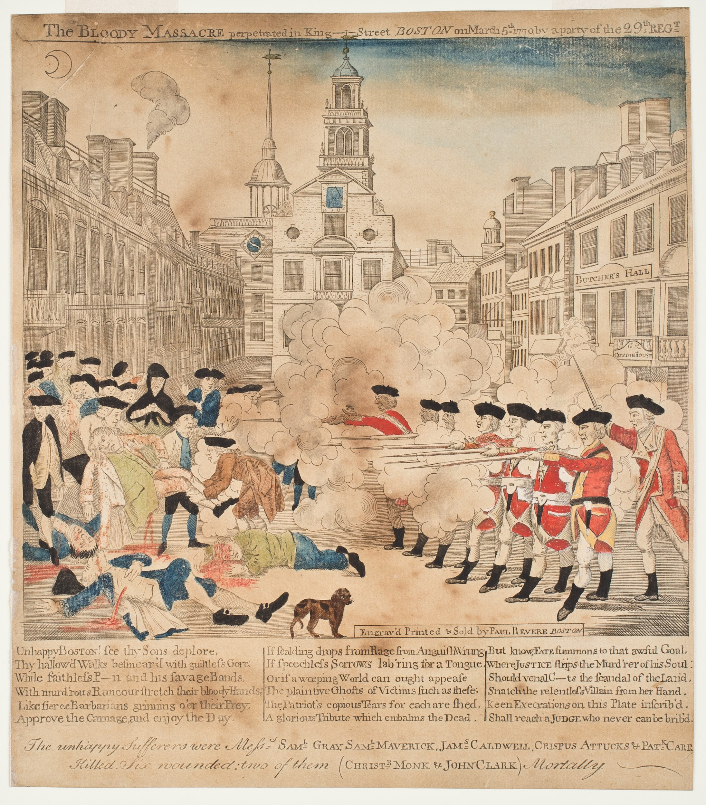
THE BLOODY MASSACRE ENGRAVING
Created by Paul Revere in 1770
TEXT FROM THE ENGRAVING’S CAPTION
Top: “The BLOODY MASSACRE perpetrated in King Street BOSTON on March 5th, 1770 by a party of the 29th REGT”

Bottom: “Engrav’d Printed & Sold by Paul Revere, BOSTON

Unhappy BOSTON! see thy Sons deplore, Thy hallowe'd Walks besmear'd with guiltless Gore: While faithless P---n and his savage Bands, With murd'rous Rancour stretch their bloody Hands; Like fierce Barbarians grinning o'er their Prey, Approve the Carnage, and enjoy the Day.
[...]
The unhappy Sufferers were Messs. SAM. L GRAY, SAM.L MAVERICK, JAM.S CALDWELL , CRISPUS ATTUCKS & PAT.K CARR Killed. Six wounded two of them (CHRIST.R MONK & JOHN CLARK) Mortally”

GUIDING QUESTIONS
Note: Below are questions students will answer on their Document Analysis worksheet. We’ve provided example answers in blue for your reference.

- Who was Paul Revere? What do you know about his life?

Paul Revere was a colonist in Boston. He was a Patriot and a member of the Sons of Liberty. He didn’t
like British taxes because he thought colonists should have representatives in Parliament if they were going to get
taxed. He was a silversmith who made engravings too. He created this print and another print about the Troops Landing after the Boston Massacre happened.
- What did Paul Revere see? According to Revere’s “Bloody Massacre” print, what caused the Boston Massacre? Consider both the image and the text of the print. Why would he choose to depict the event this way?
According to Paul Revere, the Massacre was all the fault of the British soldiers. He calls them “fierce barbarians”

and says that they enjoy shooting colonists. He makes the colonists look very helpless and there is one soldier,

probably meant to be Captain Preston, who is commanding his soldiers to fire. He would likely have depicted the massacre this way because of his feelings about the British and British soldiers. He thought the British were taking away colonial freedoms by taxing them and sending soldiers to enforce the taxes.

- What would a Loyalist see? How would a pro-British artist have depicted the same scene? What would change in the image and the text? Hypothesize and describe your predicted similarities or changes below.
A Loyalist or British artist would have depicted the scene differently to be more sympathetic to the soldiers. For

example, they would make the crowd of colonists look more dangerous, and include the snowballs or armed men. If

they believed Captain Preston’s story, they would show him trying to calm his men down, not ordering them to fire. They would do this because they saw the colonists as disobedient and not trustworthy.

- What would a historian see? For centuries, Paul Revere’s “Bloody Massacre” has been the defining representation of the shooting on March 5, 1770. In the space below, create your own visual interpretation of the Boston Massacre and its causes. Use images and text to help your audience understand that the Boston Massacre was more than just an isolated tragedy on the night of March 5th.

APPENDIX
BACKGROUND INFORMATION
An overview of some key events leading up to the Boston Massacre.

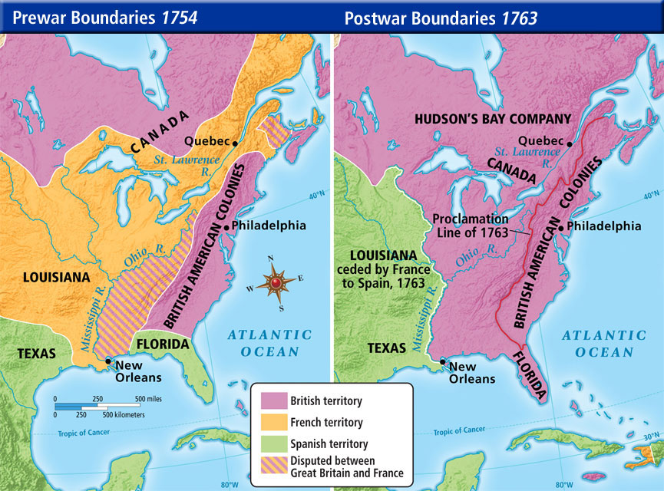
1754-1763: The French and Indian War
A lengthy conflict between rival colonial powers, Great Britain and France. The British emerge as victors, and sign a treaty, the Proclamation of 1763, giving them new territory in North America. But winning comes at a steep price, and the British national debt explodes.

1763: The case for and against a standing army
After the war, the British prime minister wants to keep thousands of soldiers stationed in the American colonies. Parliament justifies the cost by saying that soldiers are needed to defend the frontier against Indians. But critics in Britain and the colonies strongly oppose the idea of a standing army during peacetime as a waste of money and a threat to liberty.
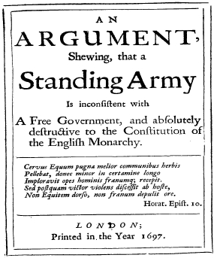
1764: Sugar Act
Parliament still needs to increase revenue. But raising taxes in Britain is risky - there were major protests the last time they tried. Parliament decides it is time for the colonists to contribute!

In 1764, Parliament passes an act taxing sugar and molasses imports in the American colonies. People in Boston whose livelihoods depended on this trade, write petitions and articles denouncing the Sugar Act, stating it violates the principle of self-rule. According to British common law, taxes can only be imposed with consent from the people through their elected representatives, and since the colonists are not allowed to elect representatives to serve in Parliament, they argue this is a blatant case of taxation without representation!

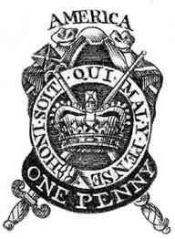
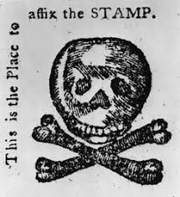
1765-66: Stamp Act Riot and Repeal
Parliament is not moved by the colonists’ arguments against the Sugar Act, and passes the Stamp Act to raise more money. The new law says that colonists have to pay a small amount of money for a stamp on all printed goods -- newspapers, legal and commercial documents, books, playing cards. A tax like this will affect nearly everyone and increase tensions across the thirteen colonies.
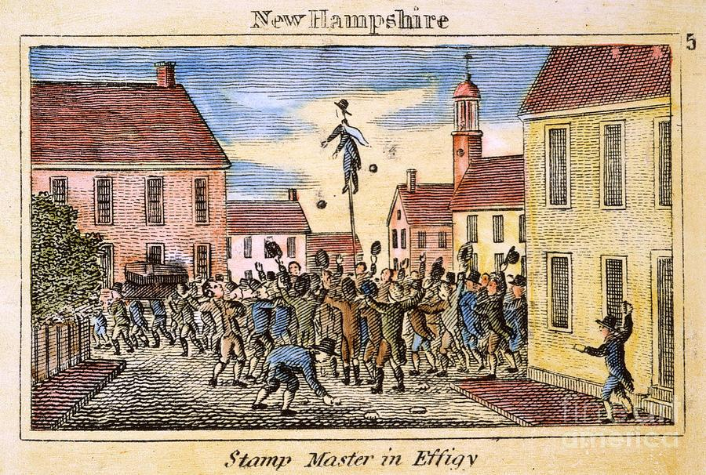
A small group of colonists, calling themselves the Sons of Liberty forms a secret organization in protest. While they continue to write petitions against the Stamp Act, they also take more direct action. They hire gangs to intimidate Boston’s tax collector who they hang in effigy (a crude model of a person for the purposes of destroying in protest). The resistance grows to the point where a mob of two thousand people riot in the streets and destroy the Lieutenant Governor’s mansion. With no one willing to enforce the Stamp Act, Parliament decides to repeal the law in 1766 (while passing another law saying that it still has the right to tax the colonies at any point).

1767: The Townshend Duties
Parliament follows the repeal of the Stamp Act with a new set of taxes the next year, passing the Townshend Duties, which taxes British imports of glass, lead, paints, paper and tea. This time Parliament also sends special Customs Commissioners to the colonies to enforce the new regulations.

Patriot groups such as the Sons of Liberty respond by organizing “non-importation” boycotts throughout the colonies. Merchants are asked not to sell imported goods, and townspeople not to buy them and to use locally made goods instead. Some townspeople in Boston also continue to harass the Commissioners.

The Commissioners writes to Parliament to send military protection and support, and, in 1768, troops begin to arrive in Boston. By 1769, there are as many as 2,000 British soldiers in a town of 15,000.
APPENDIX
DOCUMENT REFERENCE
As students navigate Boston in the VR interactive they hear about the multiple causes that built tension that might have contributed to the Boston Massacre. Each time they hear a cause this is logged as a field note they’ve collected. Their field notes are emailed at the end so students can reflect on what they’ve learned and incorporate it into further learning tasks. Below is an example of a Field Notes printout.
