Document Analysis: The Bloody Massacre engraving
Created by Paul Revere 1770
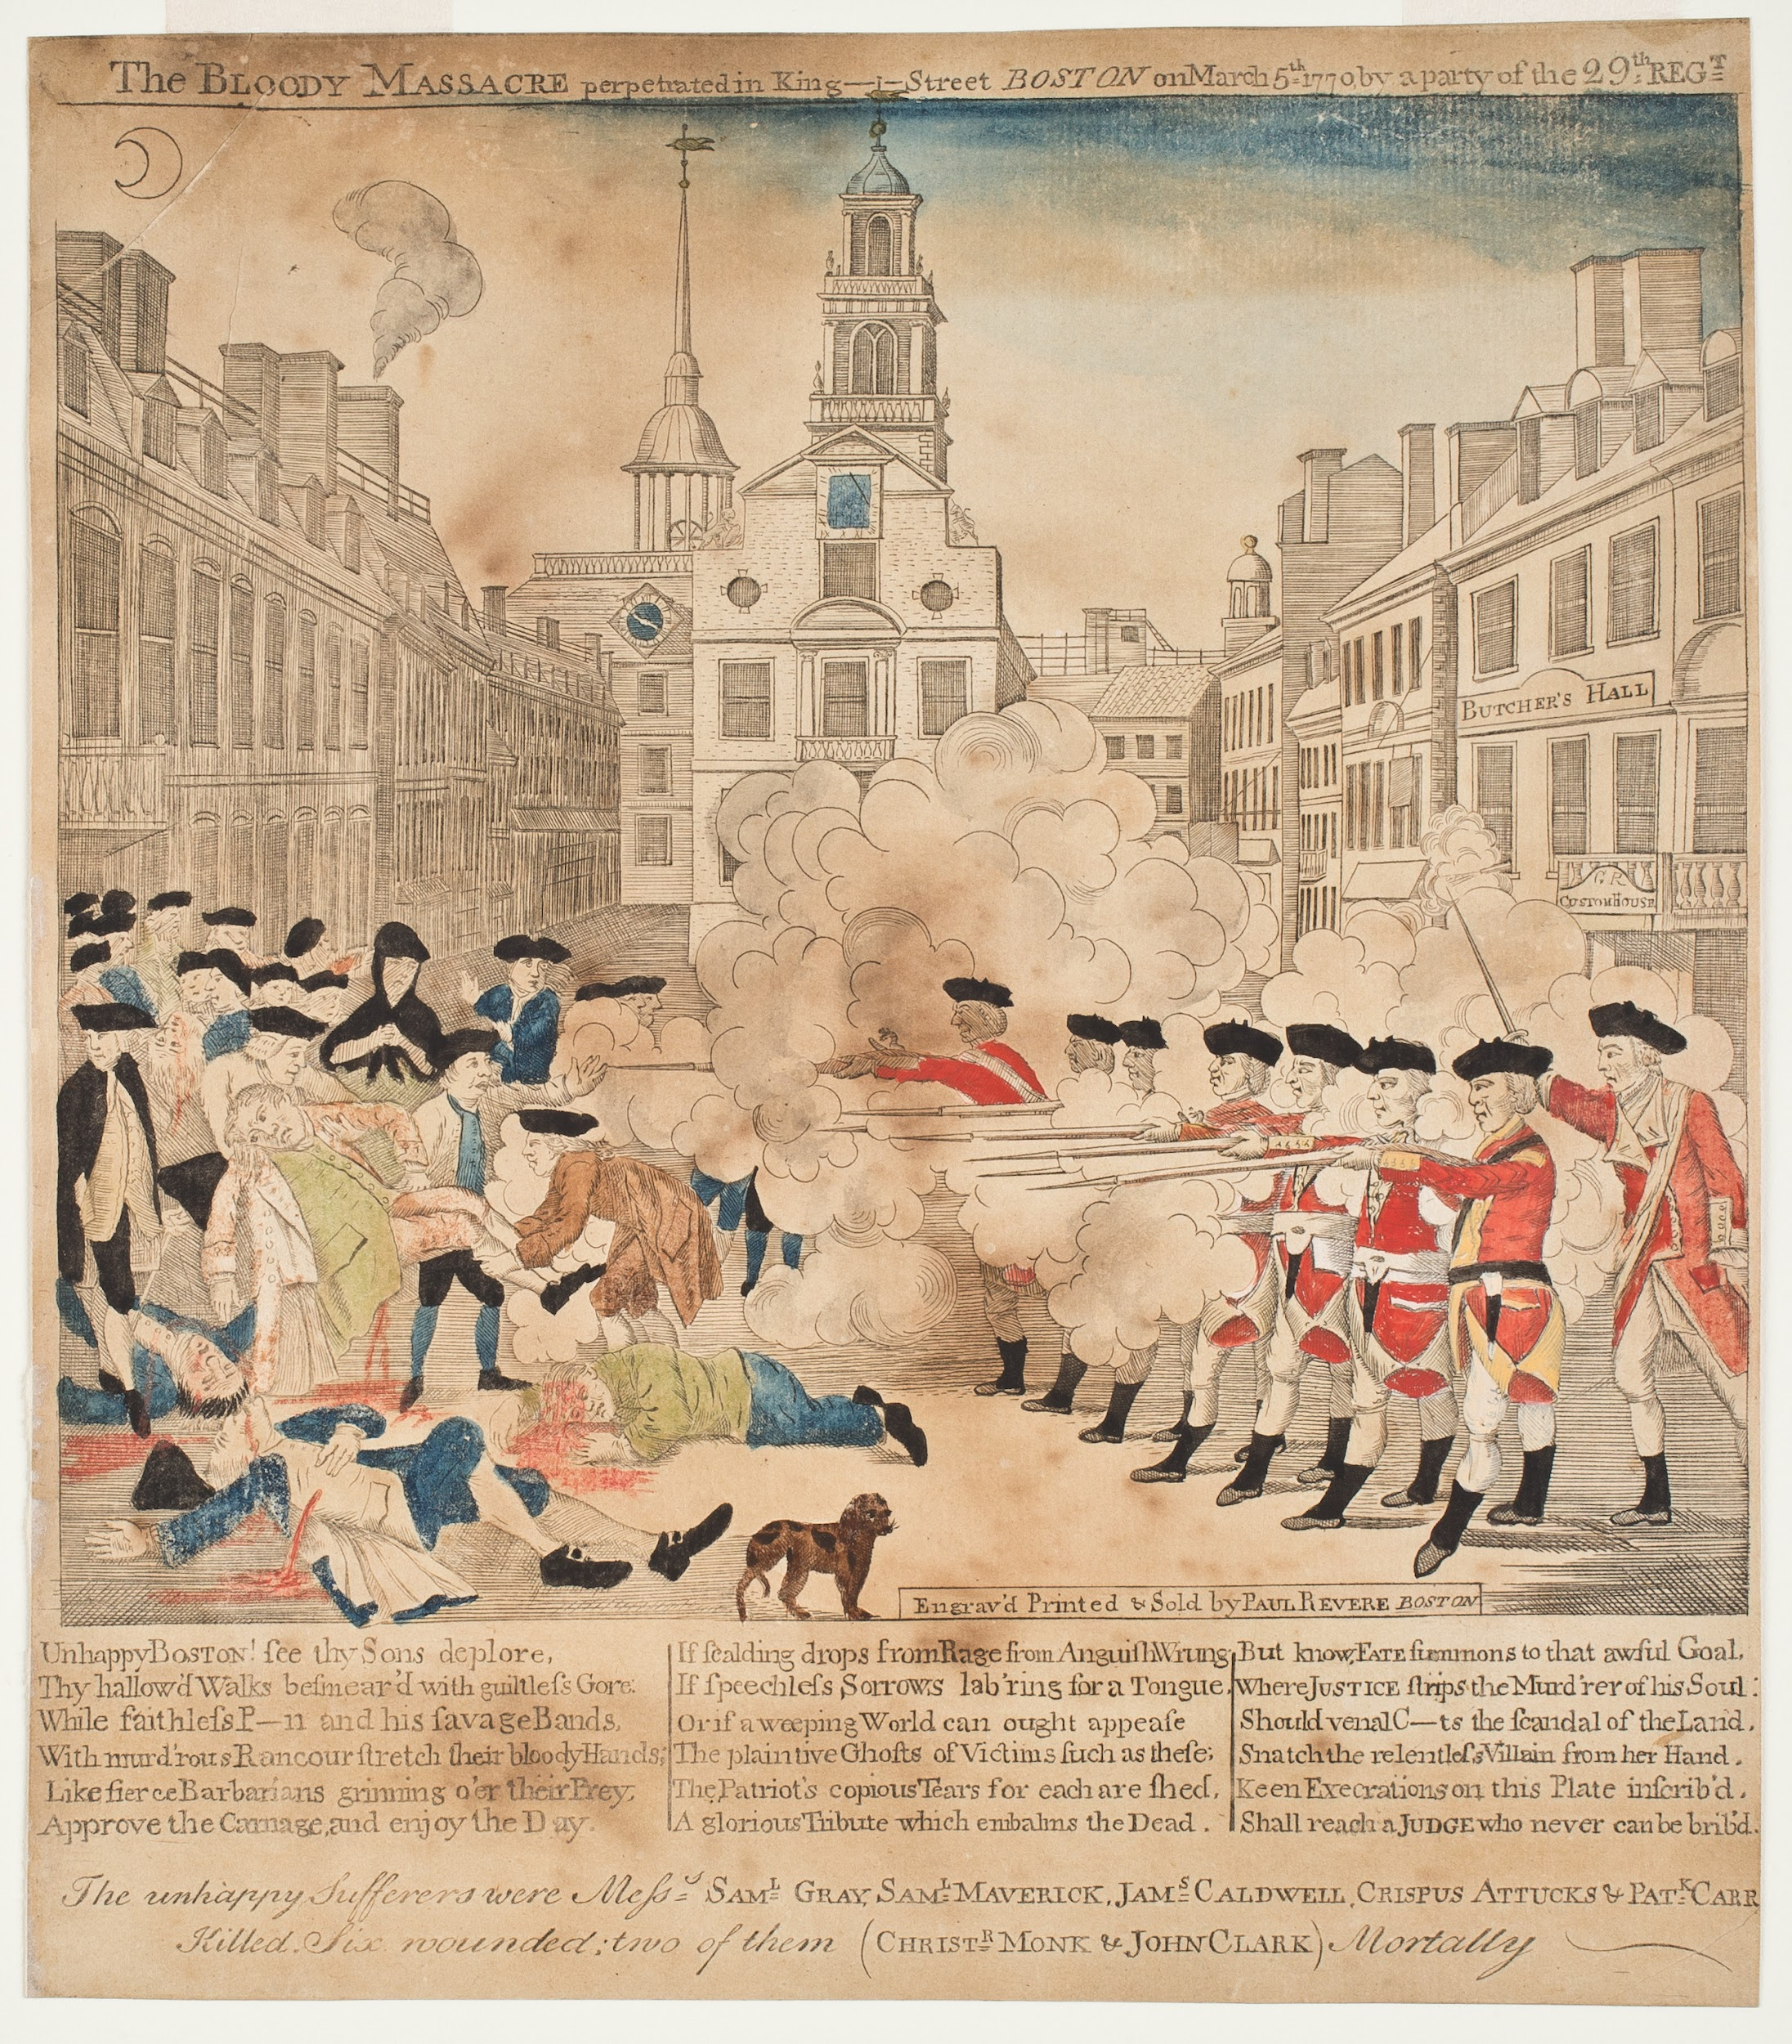
Text from the engraving’s caption
Top: “The BLOODY MASSACRE perpetrated in King Street BOSTON on March 5th, 1770 by a party of the 29th REGT”

Bottom: “Engrav’d Printed & Sold by Paul Revere, BOSTON

Unhappy BOSTON! see thy Sons deplore, Thy hallowe'd Walks besmear'd with guiltless Gore: While faithless P---n and his savage Bands, With murd'rous Rancour stretch their bloody Hands; Like fierce Barbarians grinning o'er their Prey, Approve the Carnage, and enjoy the Day.
[...]
The unhappy Sufferers were Messs. SAM. L GRAY, SAM.L MAVERICK, JAM.S CALDWELL , CRISPUS ATTUCKS & PAT.K CARR Killed. Six wounded two of them (CHRIST.R MONK & JOHN CLARK) Mortally”

Answer the following questions about the “Bloody Massacre” print and conflicting perspectives on the Massacre.

- Who was Paul Revere? What do you know about his life?
_____________________________________________________________________
_____________________________________________________________________
_____________________________________________________________________
_____________________________________________________________________

- What did Paul Revere see? According to Revere’s “Bloody Massacre” print, what caused the Boston Massacre? Consider both the image and the text of the print. Why would he choose to depict the event this way?
_____________________________________________________________________
_____________________________________________________________________
_____________________________________________________________________
_____________________________________________________________________
_____________________________________________________________________
_____________________________________________________________________

- What would a Loyalist see? How would a pro-British artist have depicted the same scene? What would change in the image and the text? Hypothesize and describe your predicted similarities or changes below.
_____________________________________________________________________
_____________________________________________________________________
_____________________________________________________________________
_____________________________________________________________________
_____________________________________________________________________
_____________________________________________________________________
- What would a historian see? For centuries, Paul Revere’s “Bloody Massacre” has been the defining representation of the shooting on March 5, 1770. In the space below, create your own visual interpretation of the Boston Massacre and its causes. Use images and text to help your audience understand that the Boston Massacre was more than just an isolated tragedy on the night of March 5th.

