LESSON PLAN
The Fugitive Slave Law
Mission US TimeSnap is an interactive learning experience that combines an immersive game and evidence analysis to engage and support learners in the development of historical thinking skills and understanding of key events in U.S. history.
TABLE OF CONTENTS

Overview 1

Schedule (VR & Web Streaming) 2

Mission Brief 4

Mission Debrief 5

Field Note Analysis 7

Class Discussion Guide 10

Performance Task Guide 12

Appendix 15

OVERVIEW
How did the Fugitive Slave Law of 1850 mobilize resistance and fuel sectionalism?
Event Overview: When Henry Clay proposed a new set of laws to Congress in February, 1850, it was to “restore peace and quiet and harmony and happiness to this country.” These laws, collectively known as the Compromise of 1850, admitted California to the Union as a free state, abolished the slave trade in Washington D.C., opened southwestern territories to popular sovereignty, and strengthened the Fugitive Slave Law of 1793.

Far from “restoring peace” to the Union, this final provision, known as the Fugitive Slave Law of 1850, inflamed the latent sectional crisis.

Guiding Questions: What were the effects of the Fugitive Slave Law of 1850 in Northern communities? How did the terror and outrage the law provoked mobilize resistance and reinvigorate the abolition movement? How did these consequences contribute to the explosive sectional crisis of the 1850s?
THE EVIDENCE  - Students’ Field Notes produced while using the VR interactive or web streaming experience. | OBJECTIVES  - Identify the effects of the Fugitive Slave Law  - Contextualize and analyze the efforts of abolitionists and others to challenge or circumvent the law | MATERIALS  - TimeSnap Lesson  - Classroom plan and Instructions  - Mission Intro Script  - Documents & Document Analysis Worksheets  - TimeSnap VR App or web stream  - TimeSnap VR Field Notes
SCHEDULE: FOR VR EXPERIENCE

CLASSROOM PLAN FOR BLOCK PERIODS (80-90 minutes)
Assumes 2:1 student to device ratio

DAY 1
- Educator Intro (5 mins)
- Assign class into group A and group B (if a different student to device ratio, more or fewer groups will be needed)
- Group A VR Time (20-30 minutes)
  - Group b: Reading or teacher-assigned activity
- Group B VR Time (20-30 minutes)
  - Group A: Reading or teacher-assigned activity
- Whole class Mission Debrief (10 mins)
DAY 2
- Field note analysis worksheet (15 mins)
- Guided class discussion (25 mins)
- Performance task: Document Analysis (15 mins)

CLASSROOM PLAN FOR NON-BLOCK PERIODS (40-50 minutes)
Assumes 2:1 student to device ratio

DAY 1
- Educator Intro (5 mins)
- Assign class into group A and group B (if a different student to device ratio, more or fewer groups will be needed)
- Group A VR Time (20-30 minutes)
  - Group B: Reading or teacher-assigned activity

DAY 2
- Group B VR Time (20-30 minutes)
  - Group A: Reading or teacher-assigned activity
- Whole class Mission Debrief (10 mins)

DAY 3
- Field note analysis worksheet (15 mins)
- Guided class discussion (25 mins)

DAY 4 ( OR DAY 3 HOMEWORK)
- Performance task: Document Analysis (15 mins)
SCHEDULE: FOR WEB STREAMING EXPERIENCE

CLASSROOM PLAN FOR BLOCK PERIODS (80-90 minutes)
Assumes 1:1 student to device ratio

DAY 1
- Educator Intro (5 mins)
- Gameplay (20-30 mins)
- Field note analysis worksheet (15 mins)
- Guided class discussion (25 mins)
- Performance task: Document Analysis (15 mins)

CLASSROOM PLAN FOR NON-BLOCK PERIODS (40-50 minutes)
Assumes 1:1 student to device ratio

DAY 1
- Educator Intro (5 mins)
- Gameplay (20-30 mins)
- Whole class Mission Debrief (10 mins)

DAY 2
- Field note analysis worksheet (15 mins)
- Guided class discussion (25 mins)

DAY 3 (OR DAY 2 HOMEWORK)
- Performance task: Document Analysis (15 mins)

MISSION BRIEF
Educator Intro Script (5 minutes)
Mission US TimeSnap is an interactive learning experience that combines immersive gaming and evidence analysis to engage and support learners in the development of historical thinking skills and understanding of key events in U.S. history.
To begin, read and/or paraphrase the following intro script to the class.

Today we’ll be using a virtual reality game, Mission US’s TimeSnap to explore the Fugitive Slave Law. In September, 1850, Congress passed a set of laws known as the Compromise of 1850. Collectively, these laws admitted California to the Union as a free state, abolished the slave trade in Washington D.C., allowed southwestern territories to vote on the status of slavery, and strengthened an earlier fugitive slave act. It’s that last provision, known as the Fugitive Slave Law of 1850, that you’ll be investigating today.

In this game, you play a field agent at Chronological Advanced Research Projects Agency (C.A.R.P.A), a fictional government agency dedicated to recovering the past in order to improve the present. One main goal of C.A.R.P.A. is to rebuild the world’s archives. C.A.R.P.A has engineered a virtual form of time travel that recreates scenes from the past.

Your Mission is to discover the effects of the Fugitive Slave Law. What did the law say? How did it affect daily life in Northern states? How did the law affect different people differently? In what way did it disrupt local politics and society? Once you complete your mission, you will be asked to consider how the law contributed to the explosive sectional crisis of the 1850s.

You will answer these questions by “Time Snapping” to three locations in Northern states during the 1850s, where enforcement was in full swing. You will explore a series of defined coordinates related to the law and collect field notes. When you return to your home base, you will file a mission reporting explaining the effects of the law across Northern society.

MISSION DEBRIEF
Entire Class Activity Guide for non-block periods (10 minutes)

In this guided discussion, collect students’ first impressions coming out of the VR mission and help them make sense of events geographically and thematically. First, you will elicit the events they remember from the game experience in each location, and then you will ask them to list the individuals they interacted with. They will use this information when they go to fill out their field notes. If students do not come up with events or people, it is OK to help them remember.

TEACHER PROMPTS:

- Let’s review your mission. You were asked to discover the effects of the Fugitive Slave Law. Before you go work on your own, let’s discuss what we think happened after the law was passed. In the TimeSnap Mission, you visited a number of different places during the 1850s. Can someone tell me what events you remember taking place in each location?
Teaching note: Locations & Events include: Christiana, Pennsylvania (attack on a home by an enslaver, planned resistance by fugitives and allies); Boston, Massachusetts (arrest of a fugitive by a slave catcher; mention of a previous fugitive who was similarly kidnapped); Cincinnati, Ohio (legal appeal on behalf of a man arrested by a slave catcher; arrival of an unrelated slave catcher)

- What is similar about the events in each location? Different?
Teaching Note: Ex. of similarities→ danger to free and escaped Black residents; appearance of slave catchers/kidnappers in all states; use of courts and/or marshalls to enforce the law; resistance to the law. Ex. of differences → formal legal proceedings in cities vs. midnight attack in rural area; degree of organization in cities vs. rural area; variations in use of violence by enslavers and abolitionists; appearance of abolition tracts; degree of involvement by white abolitionists.

- What about the people you met? Did anybody stand out?
Teaching Note: Help students elicit the people they spoke with during the experience. Those people include: U.S. Marshall, man on horse, Edward Gorsuch (or enslaver), Eliza Parker (or woman in the house), man with gun, Peter H. Clark (or lawyer), judge, slave catcher, shopkeeper, Anne Warren Weston (or Abolitionist woman), Unionist man, Abolitionist man (or man with club) . Ideally, students will remember at least a few people from each location. If students don’t come up with people’s names or occupations you can help them.

FIELD NOTE ANALYSIS
Activity Guide (15 minutes)
Students will now use their CARPA field notes to write about the effects of the Fugitive Slave Law. You can distribute the field notes and have students work in pairs. The text below is the directions from the worksheet they will complete.
NOTE: The text below is from the Field Note Analysis student worksheet. Feel free to read this text with students before they start

Your field notes were logged automatically by CARPA’s A.I. technology as you explored 1850s Massachusetts, Pennsylvania, and Ohio. The A.I. has pre-sorted these notes geographically, tagged each note with the source of that information, and starred the notes that appear more than once.

To complete the CARPA Debrief Protocol, use your field notes to explain the effects of the Fugitive Slave Law.

Working in pairs...
- Review your field notes;
- Compare what you found with a partner;
- Answer the following questions.

NOTE: Below are questions students will answer using their CARPA field notes that are produced during the VR game. We’ve provided example answers in blue for your reference.

1. Review your field notes from all three locations. Identify the field notes that describe the Fugitive Slave Law itself.

- What changes did the law make to the legal code?
Ex. Anyone who helped a fugitive could be fined or arrested; Black northerners were deprived

of due process; slaveholders could force the government to help them capture escaping fugitives.

- How did those changes affect the rights & responsibilities of Northerners?
Ex. Black people in the North had their right to defend themselves in court taken away; anyone

in the North could be forced to help capture a fugitive.

2. Review the starred field notes. These are notes that you collected [could collect] in multiple locations. Describe how the Fugitive Slave Law affected life across the North?
Ex. Black Northerners were unsafe because they could now be kidnapped or arrested at any time.

Some people moved to Canada; others tried to fight slave catchers.

3. Review your field notes collected from each location.
- Describe how the people of Christiana, Pennsylvania reacted to the law. In what ways did they challenge or support the law?
Ex. Black communities worked together to defend themselves against the law because they couldn’t
rely on the state government; the government was forced to help slaveholders.

- Describe how the people of Boston, Massachusetts reacted to the law. In what ways did they challenge or support the law?
Ex. Abolitionists opposed the law, but they disagreed whether to be non-violent or violent.
People who supported the law were worried about tensions between North and South.

- Describe how people of Cincinnati, Ohio reacted to the law. In what ways did they challenge or support the law?
Ex. slave catchers travelled across the country kidnapping people to send into slavery;
Abolitionists criticized the law through religion.

- Describe one similarity and one difference between the three locations.
  - Similarity
Ex. There were Abolitionists working against the law in all locations.
  - Difference
Ex. the abolitionists had different tactics (religion, natural laws, violence vs non violence, self-defense networks).

CLASS DISCUSSION
Activity Guide (25 minutes)
In this guided discussion, you will debrief the CARPA Field Notes activity by discussing the effects of the Fugitive Slave Law and establish concrete reasons HOW each consequence relates to the law.

Then, you will discuss.
TEACHER PROMPTS— THE LAW AND ITS EFFECTS:

1. What changes to the legal system did your group notice? What rights did they change? What responsibilities did they create? ?
Teaching notes:
- Ideally, students should be able to identify the primary mechanics of the law: it stripped Black defendants of their ability to defend themselves and punished private citizens who assisted fugitives or refused to aid in the arrest of a fugitive.
- Students are given definitions for due process and habeas corpus in their field notes; if they are struggling with these terms, this is a good time to review/clarify them.
- If time, help students unpack the state/federal divide; the Fugitive Slave Law was a federal law that forced (Northern) states to comply with the local laws of other (Southern) states.

2. What starred notes did your group analyze? What communities were most heavily affected by the Fugitive Slave Law?
Teaching notes:
- The starred notes emphasize the vulnerability of all Black Northerners.
- If students have not made this connection yet, unpack why this also applied to free Black Northerners (i.e. lack of due process for anyone accused under the law made free Black people vulnerable both to kidnapping and formal arrest and trial).

3. What were some of the ways people in Christiana, Boston, and Cincinnati challenged the law?
Teaching note: For example, abolition and self-defense activity in all locations.

4. What were some of the ways people in Christiana, Boston, and Cincinnati supported the law?
Teaching note: For example, assisting with arrests, enforcing the law, criticizing opponents of the law.

*5. [for classes currently studying 1840s-1860s] Let’s take a step back. How does the Fugitive Slave Law fit into the other developments we’ve been studying in the 1840s and 50s?
Teaching note:
- Depending on the material your class has covered, might include: Mexican-American War, Compromise of 1850, abolition movement, popular sovereignty, Kansas-Nebraska Act, Dred-Scott decision.
- Students should consider why the law was passed and how it contributed to rising sectional tensions.

*5. [for classes not studying 1840-1860s or the Civil War] Let’s take a step back. In your mission brief, you learned that this law was part of a larger compromise designed to cool sectional tensions between North and South. Does the law seem to be working as intended?
Teaching note: Students should be able to identify that the law was inflammatory in the North, pointing, for example, to abolition activity and complaints by government officials and neighbors.

6. Ask students to write a short synopsis explaining the effects of the law. Distribute the “C.A.R.P.A. Mission Report” worksheet, or just give verbal instructions.
Student instructions: Individually or with your partner, write a 3-5 sentence Mission report explaining the effects of the Fugitive Slave Law. You must include:
- More than one effect;
- At least one example of a challenge to the law;
- At least one example of support for the law.

PERFORMANCE TASK GUIDE
Object Analysis: Abolition Artifacts (15 minutes)

Students will review and contextualize artifacts they encountered on their mission. You can distribute the worksheet and have students work individually. The text below is the directions from the worksheet they will complete.
Note: The text below is from the Object Analysis student worksheet. Feel free to read this text with students before they start)

The Objects
Review the following items you collected on your mission.

The Tin Horn
Created by unknown, c. 1850

CARPA Description: A small horn, made of tin. Horns were used to communicate over distances, either to summon animals or to call family or neighbors.

Uncle Tom’s Cabin
Written by Harriet Beecher Stowe, 1852

Text Transcript: “[S]ince the legislative act of 1850, when she heard… Christian and humane people actually recommending the remanding escaped fugitives into slavery, as a duty binding on good citizens… she could only think, These men and Christians cannot know what slavery is… And from this arose a desire to exhibit it in a living dramatic reality.”

Petition for Writ of Habeas Corpus
Filed in Montgomery County, Ohio, 1853

Text Transcript: Petition for a Writ of Habeas Corpus
Your Petitioner … respectfully represents that he is unjustly restrained of his liberty and without warrant, authority, or due form of law is confined… Your petitioner prays… that you will … order that he be discharged from his confinement and from the custody of all persons who unlawfully detain him.

GUIDING QUESTIONS
Note: Below are questions students will answer on their Object Analysis worksheet. We’ve provided example answers in blue for your reference.

- The Tin Horn.

  - Where did you see the tin horn in the game?

The tin horn was at the Pennsylvania farm. A woman was holding the horn. She wanted to
call her neighbors for help.

  - What field note(s) did you collect from the horn?

Black communities were helping each other by protecting their neighbors from kidnapping.
.

  - How was the tin horn used? What did its use have to do with the Fugitive Slave Law?

The woman had to use the horn to call to her neighbors because her house was being
attacked by slave catchers who were using the law against her.
- Uncle Tom’s Cabin.
  - Where did you see Uncle Tom’s Cabin in the game?

It was for sale in a bookshop in Boston.

  - What field note(s) did you collect from Uncle Tom’s Cabin?

Ex. You could get arrested for helping a fugitive; abolitionists used appeals to emotion to
.help people sympathize with fugitives and enslaved people.

  - The text excerpted in your mission and on this worksheet was taken from the author’s concluding remarks at end of the novel. According to the excerpt, why did she write this novel?

The Fugitive Slave Law made her think people really didn’t understand slavery, and she
wanted to show it to them by dramatizing it in a book.
- Petition for a Writ of Habeas Corpus.
  - Where did you see the Petition for a Writ of Habeas Corpus in the game?

It was in the judge’s office in Ohio.

  - What field note(s) did you collect from the Petition?

Ex. Abolitionists challenged the law through the courts via writs of habeas corpus.

  - According to the text excerpted in the game and on this worksheet, what did the Petition ask? What did its use have to do with the Fugitive Slave Law?

The petition was brought to the court to free a man who was arrested for being a
fugitive. He was arrested because of the law and the lawyer was trying to fight it.
- Energizing the Abolition Movement. Each of the artifacts you have examined represents a strategy used by Abolitionists and opponents of slavery to challenge the Fugitive Slave Law.

  - Compare and contrast the different strategies. How are they similar? How are they different?
Possible points of connection: the petition and the novel are non-violent and require
literacy and education to use; the tin horn and the novel unite people into a community

Possible points of difference: the use of the tin horn also leaves open the possibility of
armed self-defense; the petition relies on the courts to cooperate; the novel is likely to appeal to those already critical of slavery

  - Based on your mission, your field notes, and your knowledge from class, explain what strategy you believe was most effective.

Students might point out that direct armed resistance was the only practical way to escape
the law (and end slavery: see the Civil War); they might explain that winning “hearts and
minds” was the only way to change the law; or they might suggest that the best way to fight a
the law is with the law.

APPENDIX
BACKGROUND INFORMATION
An overview of some key events leading up to the passage of the Fugitive Slave Law.
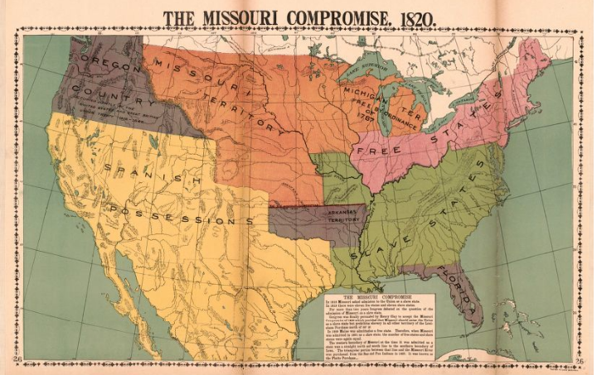
Expansion of Slavery in the Territories
In the early 1800s, the United States acquired territory through diplomacy and war. As those territories petitioned for statehood, one question emerged again and again: would that new state allow slavery? In 1820, Congress passed the Missouri Compromise, an attempt to settle the debate over slavery by setting a rule: slavery was prohibited in the new Louisiana territory north of the 36°30’ line of latitude.

Abolition and Free Soil Movements
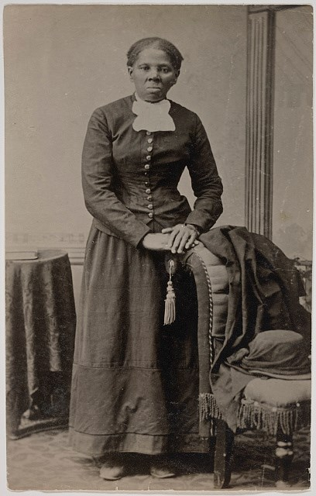
As cotton cultivation expanded in the early 19th century, so did the institution of slavery. Many people, largely in the North, began to publicly agitate against slavery. Free Soilers fought the expansion of slavery into new Western territories, arguing that free men and free labor could not compete against wealthy enslavers and their low labor costs. Abolitionists went a step further, demanding an end to slavery eveywhere. They criticized slavery as an affront to morality, religion, and natural rights, but were often dismissed as radicals and troublemakers.

The Underground Railroad
Enslaved people escaping bondage in the South might seek assistance on the Underground Railroad. This informal network of helpers, Black and white, who might provide food, shelter, transportation, or advice, assisted fugitives on their journey to freedom. The Underground Railroad was most active in the Upper South, where slave states bordered free states, and near bustling ports, where a boat could smuggle a fugitive north the quickest. Some continued their journey on the Underground Railroad all the way to Canada.

The Mexican Cession and the Compromise of 1850
As a result of the Mexican-American War (1846-48), the United States seized Mexican land in the West and Southwest. Congress returned to the old question: would these territories allow slavery? When California asked to be admitted to the Union as a free state, Southern Congressmen objected, fearing a free state majority in the Senate. To appease Southern concerns, Senator Henry Clay drafted another compromise. He proposed the admission of California as a free state, no restrictions on slavery in the other Mexican Cession terrirories, the end of the slave trade (but not slavery) in Washington, D.C., and a stronger Fugitive Slave Law. His compromise passed in 1850.
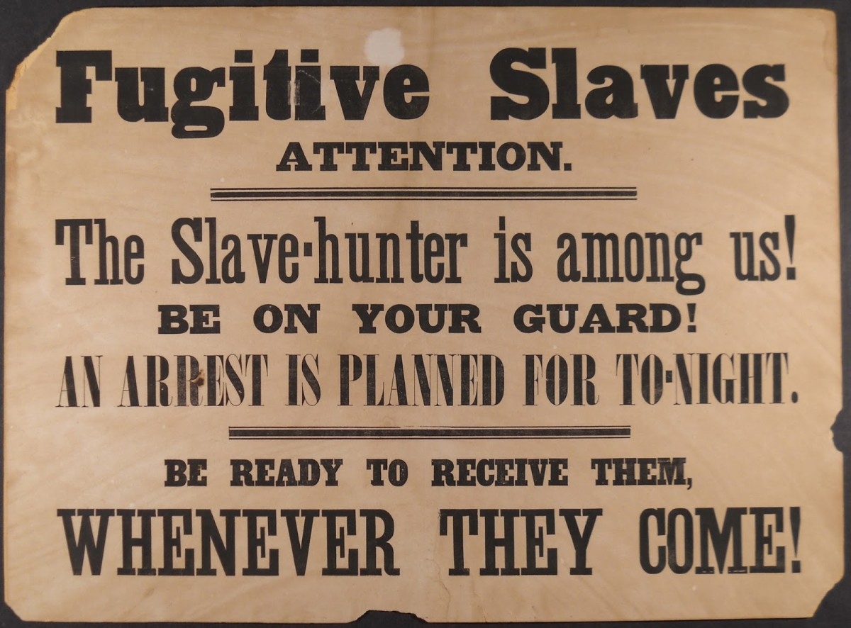
The Fugitive Slave Laws of 1793 and 1850
Of the various elements of the Compromise of 1850, the most upsetting to Northerners and most appreciated by Southerners was the new Fugitive Slave Law. There was already a law, the Fugitive Slave Law of 1793, that required local courts in free states to honor the property claims of slaveholders and punish civilians who knowingly aided fugitives. However, many Northern states had been reluctant to enforce this law, and many had passed “personal liberty laws” to undermine it.

The new law, the Fugitive Slave Law of 1850, forced federal and state governments to escalate enforcement. Federal courts, rather than local courts, were empowered to enforce the law, slaveholders did not need to document their claim to an accused fugitive, and those arrested or kidnapped under the law could not defend themselves in court.

APPENDIX
DOCUMENT REFERENCE
As students navigate the 1850s, they hear about the impact of the Fugitive Slave Law in Pennsylvania, Ohio, and Massachusetts. Each time they hear an effect it is logged as a field note they’ve collected. Their field notes are emailed at the end so students can reflect on what they’ve learned and incorporate it into further learning tasks. Below is an example of a Field Notes printout.

